

**GRIET COUNSELLING CENTER (GCC)**

**Students Psychological Wellness Study**

By

**Dr. Y. Butchi Raju, Counselling Psychologist, GRIET**



**Analysis done by Students of Indian Society for Technical Education (ISTE)**

A study on **Students Psychological Wellness** was conducted involving all B tech 1st year students of 2019 batch. The analysis of the study was done by team ISTE with active participation of **Ms. Navani Byraju,Mr. P.Santosh ,Mr. Prashant Sharma, Ms.Zafra and Ms.Neha**. I thank the team ISTE for their support without which this study would not have been completed.

In this endeavor, I am grateful to GRIET Director, **Dr Jandhyala N Murthy garu** for his valuable guidance.

My sincere thanks to the Principal, GRIET **Dr.J.Praveen garu for** his support from time to time**.**

I am extremely grateful to the Senior Administrative Officer and Dean Training, GRIET **Dr.K.V.S.Raju garu** for his continuous encouragement to me towards Student Counselling activities.

My thanks to the ISTE Coordinator of GRIET **Mr Vinay Kumar,** Faculty, EEE, Basic Sciences HOD **Dr. B.Srinivasa Rao** and its Faculty **Ms. Sravanthi**, for their Co-operation.

Psychological Wellness

## The study was conducted on 5 Parameters which are most essential in evolving the Psychological Wellness of Students

**Self-awareness:** Self-awareness is the key cornerstone to emotional intelligence. The ability to monitor our emotions and thoughts from moment to moment is key to understanding ourselves better, being at peace with who we are and proactively managing our thoughts, emotions, and behaviors.

**Managing Emotions:** Emotions can play an important role in how we think and behave. The emotions we feel each day can compel us to act and influence the decisions we make about our lives, both large and small. In order to truly understand emotions

**Motivating Oneself:** Motivation is an important life skill. The reason it’s important is because every person on this earth is unique and has a purpose. To steward your purpose well, you must be motivated to work towards your goals which helps your dreams become a reality. Not just for your sake, but the sake of others as well.

**Empathy:** Empathy involves the ability to emotionally understand what another person is experiencing. Essentially, it is putting yourself in someone else's position and feeling what they must be feeling. When you see another person suffering, you might be able to instantly envision yourself in the other person's place and feel sympathy for what they are going through.

**Social Skills:** Human beings are inherently social creatures. As far back as we can trace, humans have traveled, hunted, and thrived in social groups and for good reason. Humans who were separated from their tribe often suffered severe consequences. Social groups provide us with an important part of our identity, and more than that, they teach us a set of skills that help us to live our lives.

Psychological Wellness Test for Students

YOUR SCORE **1**-indicates that the statement **does NOT apply at all to You**  **2**-indicates that the statement **Sometimes applies to You 3**-indicates that the statement **applies about half the time to You** **4**-indicates that the statement **applies** **Most of the time to you 5**-indicates that the statement **ALWAYS applies to you**

 **How much does each statement apply to you** **Mark your score**

|  |  |  |  |  |  |  |
| --- | --- | --- | --- | --- | --- | --- |
| **1** | I realize immediately when I lose my temper | **1** | **2** | **3** | **4** | **5** |
|  |  |  |  |  |  |  |
| **2** | I can 'refrain' bad situations quickly | **1** | **2** | **3** | **4** | **5** |
|  |  |  |  |  |  |  |
| **3** | I can always motive myself to do difficult tasks | **1** | **2** | **3** | **4** | **5** |
|  |  |  |  |  |  |  |
| **4** | I am always able to see things from the other person's viewpoint | **1** | **2** | **3** | **4** | **5** |
|  |  |  |  |  |  |  |
| **5** | I am an excellent listener | **1** | **2** | **3** | **4** | **5** |
|  |  |  |  |  |  |  |
| **6** | I know when I am happy | **1** | **2** | **3** | **4** | **5** |
|  |  |  |  |  |  |  |
| **7** | I do not display my feelings openly | **1** | **2** | **3** | **4** | **5** |
|  |  |  |  |  |  |  |
| **8** | I am usually able to prioritize important activities at work and get on with them | **1** | **2** | **3** | **4** | **5** |
|  |  |  |  |  |  |  |
| **9** | I am excellent at empathizing with someone else's problem | **1** | **2** | **3** | **4** | **5** |
|  |  |  |  |  |  |  |
| **10** | I never interrupt other people's conversations | **1** | **2** | **3** | **4** | **5** |
|  |  |  |  |  |  |  |
| **11** | I usually recognize when I am stressed | **1** | **2** | **3** | **4** | **5** |
|  |  |  |  |  |  |  |
| **12** | Others can rarely tell what kind of mood I am in | **1** | **2** | **3** | **4** | **5** |
|  |  |  |  |  |  |  |
| **13** | I always meet deadlines | **1** | **2** | **3** | **4** | **5** |
|  |  |  |  |  |  |  |
| **14** | I can tell if someone is not happy with me | **1** | **2** | **3** | **4** | **5** |
|  |  |  |  |  |  |  |
| **15** | I am good at adapting and mixing with a variety of people | **1** | **2** | **3** | **4** | **5** |
|  |  |  |  |  |  |  |
| **16** | When I am being 'emotional' I am aware of this | **1** | **2** | **3** | **4** | **5** |
|  |  |  |  |  |  |  |
| **17** | I rarely lose temper suddenly at other people | **1** | **2** | **3** | **4** | **5** |
|  |  |  |  |  |  |  |
| **18** | I never waste time | **1** | **2** | **3** | **4** | **5** |
|  |  |  |  |  |  |  |
| **19** | I can tell if a team of people are not getting along with each other | **1** | **2** | **3** | **4** | **5** |
|  |  |  |  |  |  |  |
| **20** | People are the most interesting thing in life for me | **1** | **2** | **3** | **4** | **5** |
|  |  |  |  |  |  |  |
| **21** | When I feel anxious, I usually can account for the reason(s) | **1** | **2** | **3** | **4** | **5** |
|  |  |  |  |  |  |  |
| **22** | Difficult people do not annoy me | **1** | **2** | **3** | **4** | **5** |
|  |  |  |  |  |  |  |
| **23** | I do not act in an evasive way | **1** | **2** | **3** | **4** | **5** |
|  |  |  |  |  |  |  |
| **24** | I can usually understand why people are being difficult towards me | **1** | **2** | **3** | **4** | **5** |
|  |  |  |  |  |  |  |
| **25** | I love to meet new people and get to know what makes them to behave certain way | **1** | **2** | **3** | **4** | **5** |
|  |  |  |  |  |  |  |

**2 of 3**



**#** **How much does each statement apply to you** **Mark your score**

|  |  |  |  |  |  |  |
| --- | --- | --- | --- | --- | --- | --- |
| **26** | I always know when I'm being unreasonable | **1** | **2** | **3** | **4** | **5** |
|  |  |  |  |  |  |  |
| **27** | I can consciously alter my frame of mind or mood | **1** | **2** | **3** | **4** | **5** |
|  |  |  |  |  |  |  |
| **28** | I believe you should do the difficult things first | **1** | **2** | **3** | **4** | **5** |
|  |  |  |  |  |  |  |
| **29** | Other individuals are not 'difficult' just 'different' | **1** | **2** | **3** | **4** | **5** |
|  |  |  |  |  |  |  |
| **30** | I need a variety of work colleagues to make my job interesting | **1** | **2** | **3** | **4** | **5** |
|  |  |  |  |  |  |  |
| **31** | Awareness of my own emotions is very important to me at all times | **1** | **2** | **3** | **4** | **5** |
|  |  |  |  |  |  |  |
| **32** | I do not let stressful situations or people affect me once I have left work | **1** | **2** | **3** | **4** | **5** |
|  |  |  |  |  |  |  |
| **33** | Delayed gratification for better future is a virtue that I hold to | **1** | **2** | **3** | **4** | **5** |
|  |  |  |  |  |  |  |
| **34** | I can understand if I am being unreasonable | **1** | **2** | **3** | **4** | **5** |
|  |  |  |  |  |  |  |
| **35** | I like to ask questions to find out what it is important to people | **1** | **2** | **3** | **4** | **5** |
|  |  |  |  |  |  |  |
| **36** | I can tell if someone has upset or annoyed me | **1** | **2** | **3** | **4** | **5** |
|  |  |  |  |  |  |  |
| **37** | I rarely worry about work or life in general | **1** | **2** | **3** | **4** | **5** |
|  |  |  |  |  |  |  |
| **38** | I believe in 'Action this Day' | **1** | **2** | **3** | **4** | **5** |
|  |  |  |  |  |  |  |
| **39** | I can understand why my actions sometimes offend others | **1** | **2** | **3** | **4** | **5** |
|  |  |  |  |  |  |  |
| **40** | I see working with difficult people as simply a challenge to win them over | **1** | **2** | **3** | **4** | **5** |
|  |  |  |  |  |  |  |
| **41** | I can let anger 'go' quickly so that it no longer affects me | **1** | **2** | **3** | **4** | **5** |
|  |  |  |  |  |  |  |
| **42** | I can suppress my emotions when I need to | **1** | **2** | **3** | **4** | **5** |
|  |  |  |  |  |  |  |
| **43** | I can always motivate myself even when I feel low | **1** | **2** | **3** | **4** | **5** |
|  |  |  |  |  |  |  |
| **44** | I can sometimes see things from others' point of view | **1** | **2** | **3** | **4** | **5** |
|  |  |  |  |  |  |  |
| **45** | I am good at reconciling differences with other people | **1** | **2** | **3** | **4** | **5** |
|  |  |  |  |  |  |  |
| **46** | I know what makes me happy | **1** | **2** | **3** | **4** | **5** |
|  |  |  |  |  |  |  |
| **47** | Others often do not know how I am feeling about things | **1** | **2** | **3** | **4** | **5** |
|  |  |  |  |  |  |  |
| **48** | Motivations has been the key to my success | **1** | **2** | **3** | **4** | **5** |
|  |  |  |  |  |  |  |
| **49** | Reasons for disagreements are always clear to me | **1** | **2** | **3** | **4** | **5** |
|  |  |  |  |  |  |  |
| **50** | I generally build solid relationships with those I work with | **1** | **2** | **3** | **4** | **5** |
|  |  |  |  |  |  |  |

**3 of 3**

**Total and interpret your results**

1. ***Record*** your 1, 2, 3, 4, 5 scores for the questionnaire statements in the grid below.The grid organizes the statements into emotional competency lists.

|  |  |  |  |  |  |  |  |  |  |  |  |  |  |
| --- | --- | --- | --- | --- | --- | --- | --- | --- | --- | --- | --- | --- | --- |
| **Self awareness** | |  | **Managing emotions** | |  | **Motivating oneself** | |  | **Empathy** | |  | **Social Skill** | |
| **1** |  |  | **2** |  |  | **3** |  |  | **4** |  |  | **5** |  |
| **6** |  |  | **7** |  |  | **8** |  |  | **9** |  |  | **10** |  |
| **11** |  |  | **12** |  |  | **13** |  |  | **14** |  |  | **15** |  |
| **16** |  |  | **17** |  |  | **18** |  |  | **19** |  |  | **20** |  |
| **21** |  |  | **22** |  |  | **23** |  |  | **24** |  |  | **25** |  |
| **26** |  |  | **27** |  |  | **28** |  |  | **29** |  |  | **30** |  |
| **31** |  |  | **32** |  |  | **33** |  |  | **34** |  |  | **35** |  |
| **36** |  |  | **37** |  |  | **38** |  |  | **39** |  |  | **40** |  |
| **41** |  |  | **42** |  |  | **43** |  |  | **44** |  |  | **45** |  |
| **46** |  |  | **47** |  |  | **48** |  |  | **49** |  |  | **50** |  |
| 2. ***Calculate*** a total for each of the 5 emotional competencies. | | | | | | | | | | |  |  |  |
|  | |  |  | |  |  | |  |  | |  |  |  |
| **Total =** |  |  | **Total =** |  |  | **Total =** |  |  | **Total =** |  |  | **Total =** |  |
| **(SA)** |  |  | **(ME)** |  |  | **(MO)** |  |  | **(E)** |  |  | **(SS)** |  |
|  |  |  |  |  |  |  |  |  |  |  |  |  |  |



**Psychological Wellness of Students- Scoring Key**

**1) Interpretation of totals for each area of competency using the following guide.**

If total Score in each of the Parameters is

**35-50** -**this area is a strength for you.**

**Less than 35-** **Requires Professional Guidance**.

**2) Record your result for each of the emotional competencies:**

Transfer your scores to the calculation table and total your results.

|  |  |  |
| --- | --- | --- |
| **Parameters** | Your Strength | Requires  Professional guidance |
| **Self-awareness** |  |  |
| **Managing emotions** |  |  |
| **Motivating oneself** |  |  |
| **Empathy** |  |  |
| **Social Skill** |  |  |

3) Consider your results and identify your Psychological Wellness and take guidance of college **Psychological Counsellor** to strengthen your Wellness.

**Summary of Analysis of Psychological Wellness of Students**

**1st Year Students-Civil Engineering Branch of GRIET**

A Psychological wellness test was conducted to 1st year Civil Engineering Students and conclusions were drawn. The following are the major findings.

1. Self-Awareness: 20% of students in Civil A and 13% of students in Civil B are not having proper awareness of their own feelings, emotions, weaknesses and strengths.

2. Managing Emotions: 49% of students of Civil A and 21% of Civil B are not having the ability to manage their Emotions and feelings.

3. Motivating oneself: 58% of students in Civil A and 19% of Students in Civil B are having lower levels of motivation and not having required Zeal and Enthusiasm.

4. Empathy: 21% of students in Civil A and 19% of the students in Civil B have low level of empathy towards others.

5. Social Skills: 19% of Students in Civil A and Equal percentage of students in Civil B have lower level of social skills.

### **Overall Representation of Civil Department:**

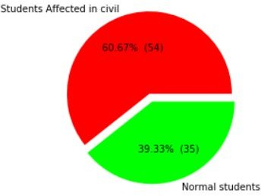

Though the diagram represents about 60% of the students affected by one or the other psychological issue. The most concerned issues among them are 1) Managing Emotions and 2) Motivating one self.

Those can be learnt by Practice under the guidance of the Psychological Counsellor. The weaknesses of the students will be addressed by the counsellor from time to time.

List of Students require Counselling / Guidance in 1st Year Civil Engineering Branch

### fl1

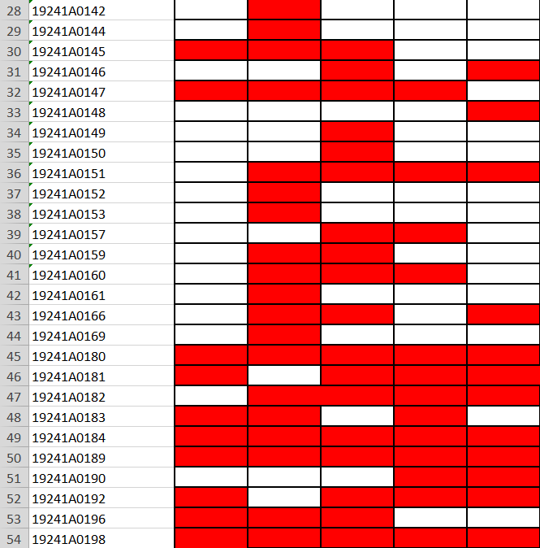

### **Detailed Analysis -Civil Engineering Branch**

### **A- Section** Total Students Participated: 92

### **Self-Awareness Among students**

### **Analysis of the given graph:** The above graph depicts the results of the psychological test on the self-awareness questions. The bars in green color indicates that the student’s score is above 35 and the bars in the red color indicates that the student’s score is less than 35. Above 35 score students have better Self-awareness.

### Less than 35 Score indicates that those students require personal counselling to enhance their Self-awareness skills.

### 

### **Analysis:** From the information shown in the above pie chart, the large green color area indicates that 80% of the students have self-awareness and these students don’t require counselling whereas the rest 20% of the students don’t seem to have self-awareness. Hence, they need to be counseled.

### Empathy among Students

### **Analysis of the given graph:** The above graph depicts the results of the behavioral test-Empathy questions attempted by the 1st year students. The bars in green colour indicates that the student’s score is above 35 and the bars in the red colour indicates that the student’s score is less than 35.

### 

### **Analysis:** From the information shown in the above pie chart, the large green color area indicates that 78.43% of the students are good at empathy and these students don’t require counselling, whereas the rest 21.56% of the students don’t seem to manage their emotions well. Hence, they need to be counseled.

### **Social Skills**

### 

### **Analysis of the given graph:** The above graph depicts the results of the behavioral test-Social Weakness questions attempted by the 1st year students. The bars in green color indicates that the student’s score is above 35 and the bars in the red color indicates that the student’s score is less than 35.

### **Analysis:** From the information shown in the above pie chart, the large green colour area indicates that 80.40% of the students do not have social weakness and these students don’t require counselling, whereas the rest 19.60% of the students have social weakness. Hence, they need to be counseled.

### **Managing Emotions:**

### **Analysis of the given graph:** The above graph depicts the results of the behavioral test-Managing Emotions questions attempted by the 1st year students. The bars in green colour indicates that the student’s score is above 35 and the bars in the red colour indicates that the student’s score is less than 35.

### 

### **Analysis**: From the information shown in the above pie chart, the large green colour area indicates that 50.98% of the students are good at managing their emotions and these students don’t require counselling, whereas the rest 49.01% of the students don’t seem to manage their emotions well. Hence, they need to be counseled

### **Motivating Oneself**

### 

### **Analysis of the given graph:** The above graph depicts the results of the behavioral test-Motivating oneself questions attempted by the 1st year students. The bars in green colour indicates that the student’s score is above 35 and the bars in the red colour indicates that the student’s score is less than 35.

### 

### **Analysis:** From the information shown in the above pie chart, the large green colour area indicates that 58.82% of the students are good at motivating themselves and these students don’t require counselling, whereas the rest 41.17% of the students don’t seem good at motivating themselves. Hence, they need to be counseled.

### **Civil -B**

### Students participated: 38

### **Self-awareness**

### 

### A **nalysis of the given graph**: The above graph depicts CIVIL-B. It shows the results of the behavioral test-self-awareness questions attempted by the 1st year students. The bars in green colour indicates that the student’s score is above 35 and the bars in the red colour indicates that the student’s score is less than 35.

### 

### A nalysis: From the information shown in the above pie chart, the large green colour area indicates that 86.36% of the students have self-awareness and these students don’t require counselling whereas the rest 13.63% of the students don’t seem to have self-awareness. Hence, they need to be counseled.

### **Managing Emotions**

### 

### A **nalysis of the given graph**: The above graph depicts the results of the behavioral test-Managing Emotions questions attempted by the 1st year students. The bars in green colour indicates that the student’s score is above 35 and the bars in the red colour indicates that the student’s score is less than 35.

### 

### A nalysis: From the information shown in the above pie chart, the large green colour area indicates that 79.16% of the students are good at managing their emotions and these students don’t require counselling, whereas the rest 20.833% of the students don’t seem to manage their emotions well. Hence, they need to be counseled.

### 

### **Motivating One self**

### 

### A nalysis of the given graph: The above graph depicts the results of the behavioral test-Motivating oneself questions attempted by the 1st year students. The bars in green colour indicates that the student’s score is above 35 and the bars in the red colour indicates that the student’s score is less than 35.

### 

### 

### Annalysis: From the information shown in the above pie chart, the large green colour area indicates that 80.85% of the students are good at motivating themselves and these students don’t require counselling, whereas the rest 19.14% of the students don’t seem good at motivating themselves. Hence, they need to be counseled.

### **Empathy**

### 

### A nalysis of the given graph: The above graph depicts the results of the behavioral test-Empathy questions attempted by the 1st year students. The bars in green colour indicates that the student’s score is above 35 and the bars in the red colour indicates that the student’s score is less than 35.

### Analysis: From the information shown in the above pie chart, the large green colour area indicates that 80.85% of the students have good empathy and these students don’t require counselling, whereas the rest 19.14% of the students don’t seem to have empathy. Hence, they need to be counseled.

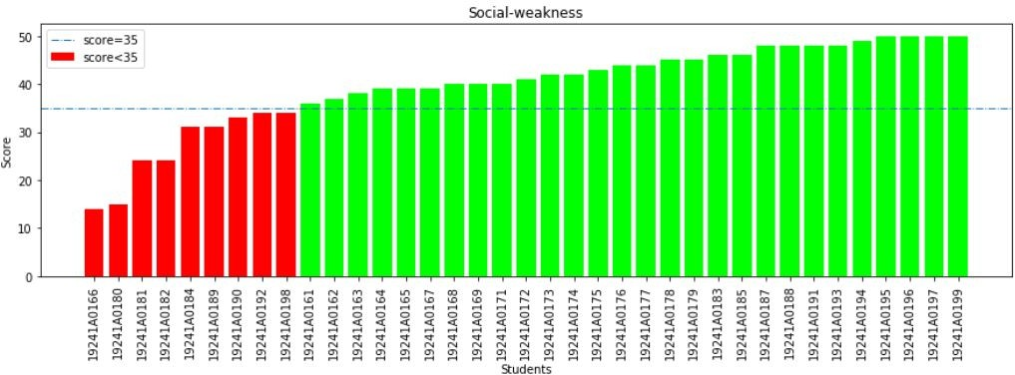**Social Skills:**

A nalysis of the given graph: The above graph depicts the results of the behavioral test-Social Skills questions attempted by the 1st year students. The bars in green colour tells that the student’s score is above 35 and the bars in the red colour tells that the student’s score is less than 35.

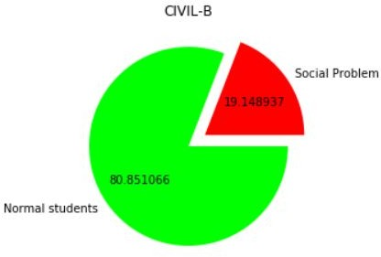

A nalysis : From the information shown in the above pie chart, the large green colour area tells that 80.85% of the students have social skills and these students don’t require counselling ,whereas the rest 19.14% of the students are not having Proper social skills. Hence, they need to be counseled.